**Junior Infants**

The Junior Infants have settled into school so well since they have started. They are becoming very independent and are even walking into school by themselves. We have had a really busy few months with fun things such as autumn apple picking, colouring competitions, science week and of course our Halloween dress up. The teachers are so proud of everybody in Junior Infants who have been working super hard with their school work also. We would like to thank all the parents for their cooperation over the last couple of months. Santa has sent some special Elves into Junior Infants in the run up to Christmas. These Elves will be causing lots of mischief but they will be reporting all the great things they see the Junior Infants doing back to Santa.





**Message from the Principal**

*The first term of the academic year 2020/2021 has certainly been very different. I want to take this opportunity to thank all the pupils, parents/guardians and staff for their cooperation; it has been an incredibly challenging time for us all but it is so great to have the school open again. It is so important that we all continue to follow the guidelines to keep us all safe. I want to thank all the parents/guardians for their enormous generosity this Christmas. Your donations helped raise over €2,000 for Milford Hospice which plays such an important role in Limerick, offering a light in the dark for many families during their most difficult of times. I want to thank you sincerely for digging deep and making a donation, it means so much to all the staff and I just know that the money will be put to good use.*

*We are all looking forward now to Christmas and have a special treat planned for Friday the 18th December. We want all the children to dig out their Christmas jumpers on this day, as we welcome the Helix Panto into our school for an online performance of their Christmas Panto.*

*On behalf of the staff and the Board of Management I would like to wish you all*

*a very happy and safe Christmas.*

*Nollaig Shona daoibh go léir.*

*Mise le meas*

*Sarah Ryan*

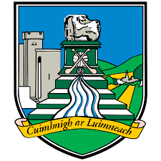



**Second Class**

After the school closure, the long lockdown and the uncertainty associated with it, 2nd class have been engaging with mindfulness and wellbeing activities which help children develop an awareness of their thoughts and emotions, as well as increasing self-awareness and an awareness of others around them.

2nd class have been busy learning prayers and developing their artwork as they prepare for their First Confession.

During Science Week, 2nd class were inspired after watching the UL Science Webinar, so later we saw some lovely home experiments which some of the boys and girls shared through Google Classroom.

The last few weeks have highlighted the importance of sport; the atmosphere has been great in school. 2nd class enjoyed the chance to make posters and banners in preparation for the big day as Limerick prepared for their second All-Ireland Final in 3 years.



**First Class**

1st class have settled back into the school routine and they are really enjoying the opportunity to meet their friends, have fun and learn new topics

They entered the Supermacs Halloween Art Competition and were over the moon when they heard that James M. in Ms.Daly’s class had won! They were given a free pizza party the following week, it was so delicious and they had so much fun. Well done to James and all the boys and girls who tried their best.

**Senior Infants**

Senior Infants went on an autumn nature walk at the beginning of the term. The children enjoyed a scavenger hunt to find different leaves and trees around the school grounds.

For Science Week, Senior Infants were very excited to do the ‘Skittles experiment’. The children were delighted to see beautiful rainbow colours emerge from the skittles when hot water was poured on top.

Some of the Senior Infants entered the Team Limerick Clean-Up Christmas competition. They entered lovely drawings and photos showing biodiversity in Limerick at winter time.

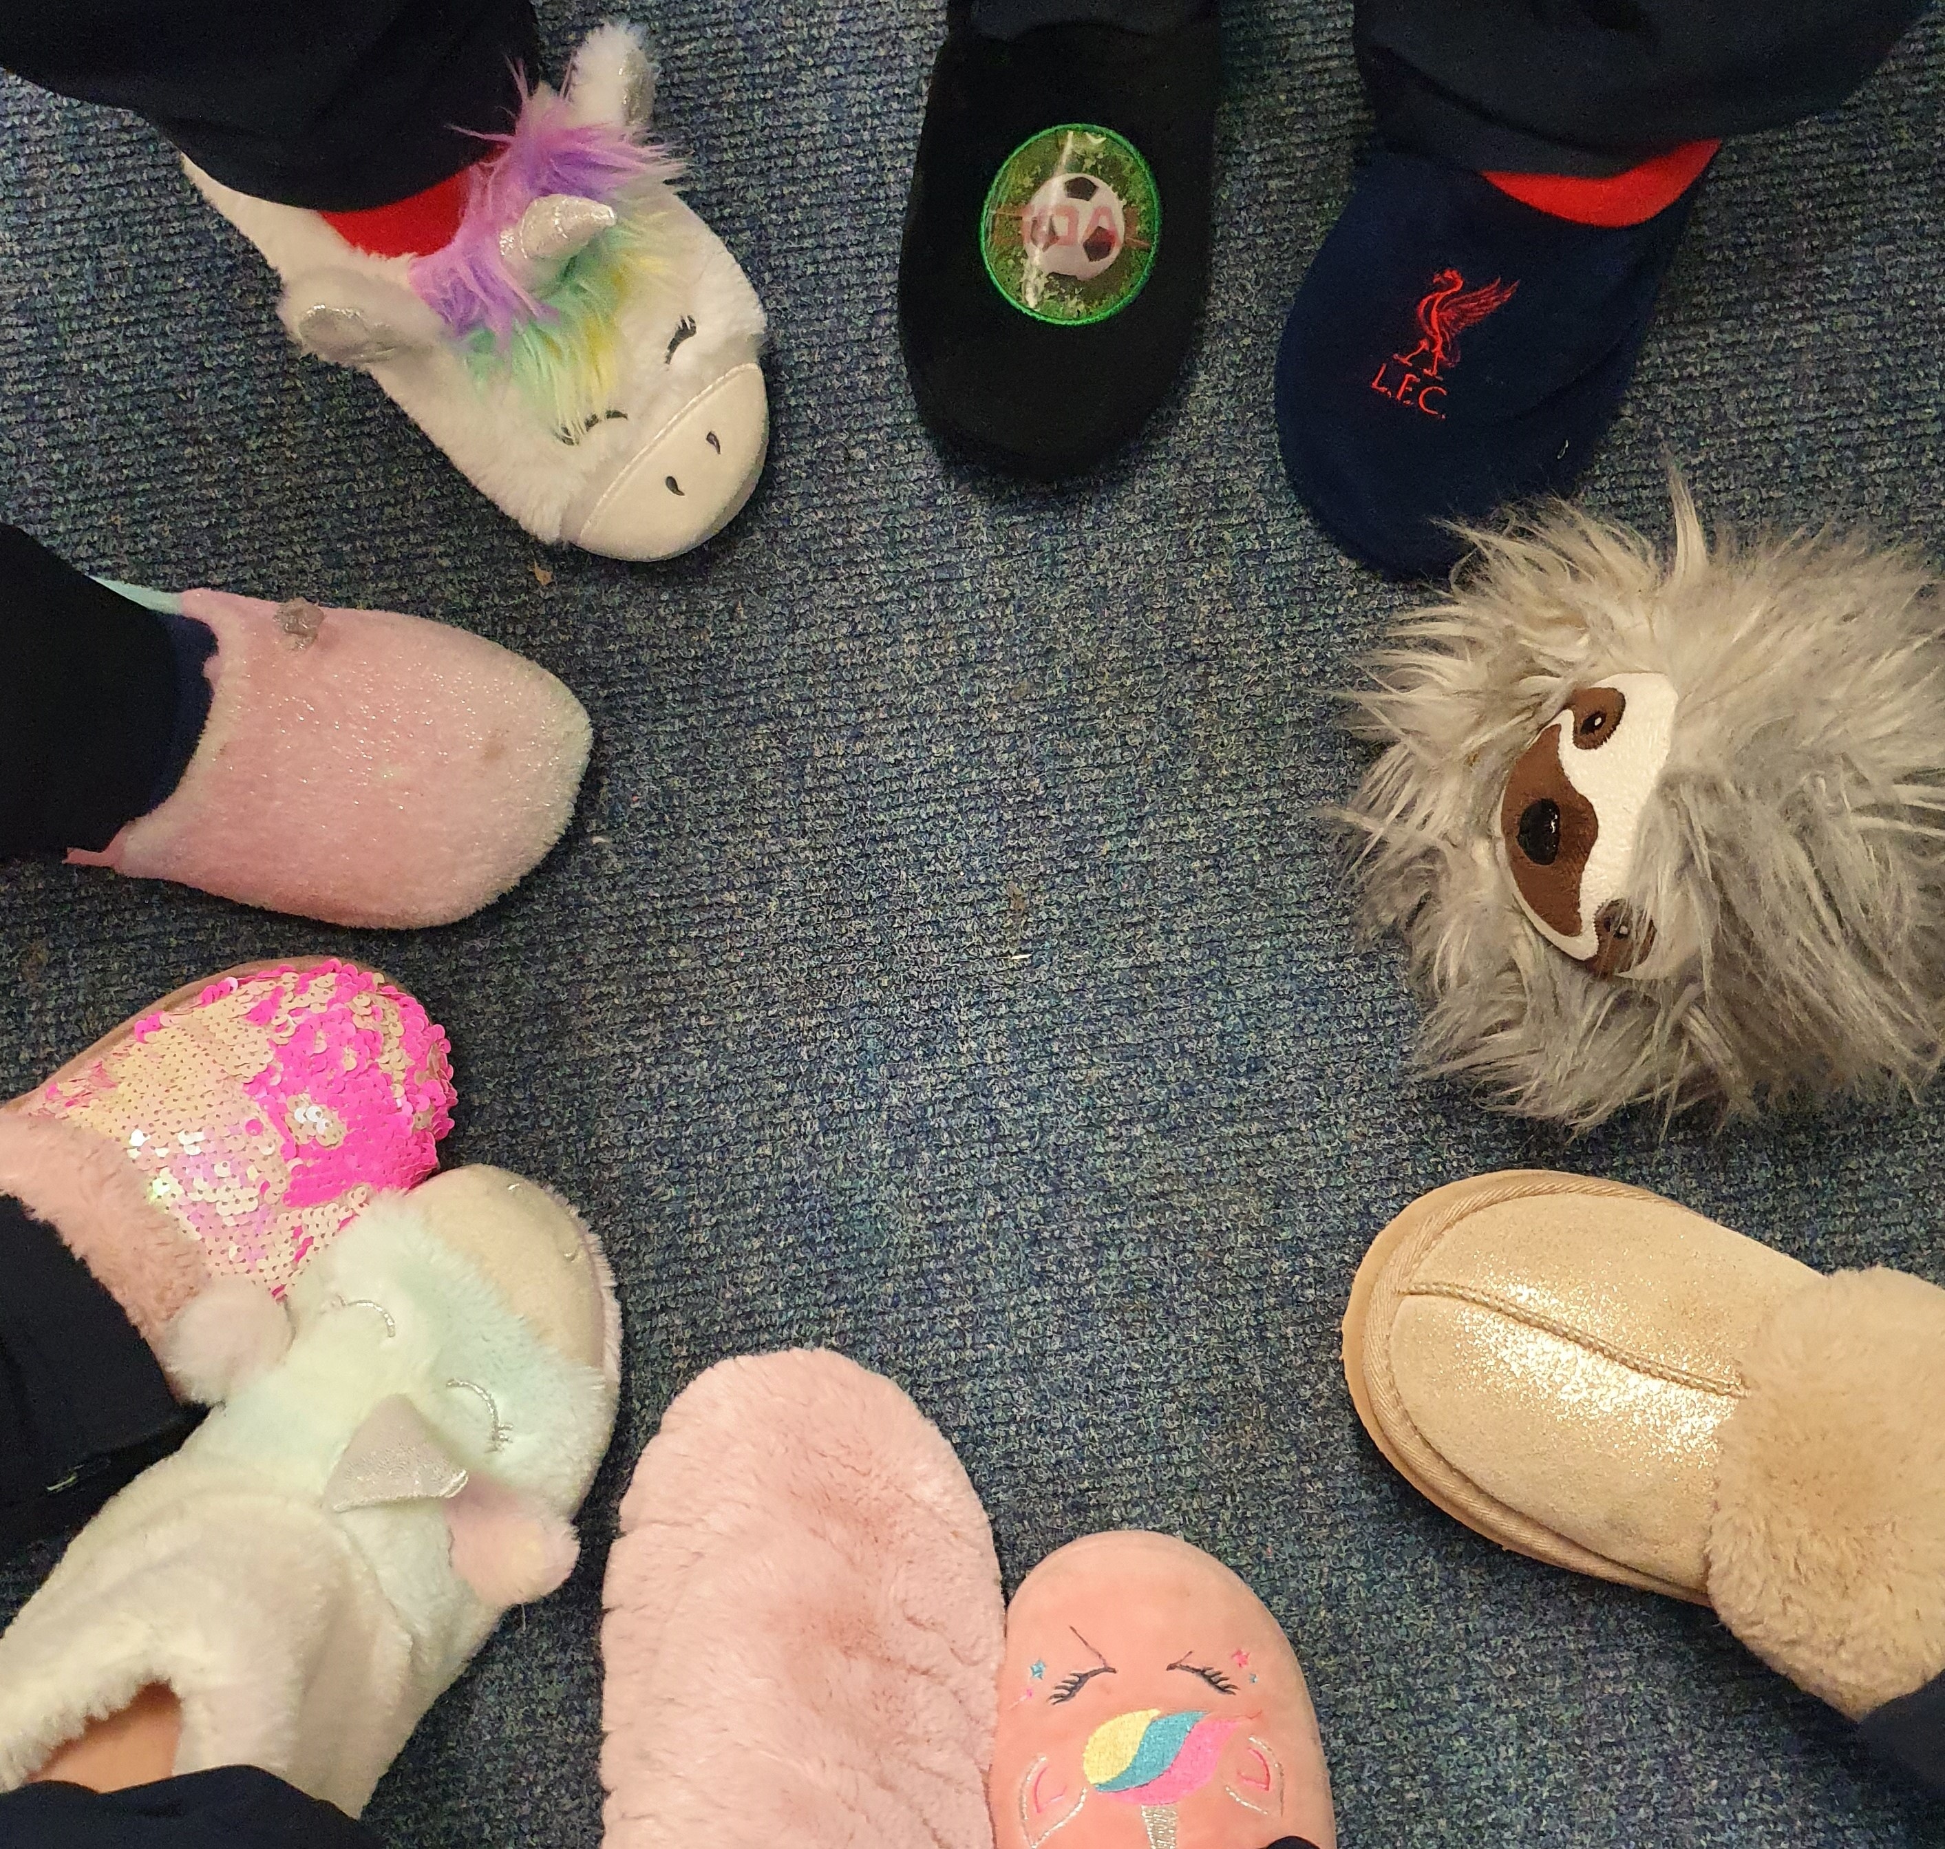 

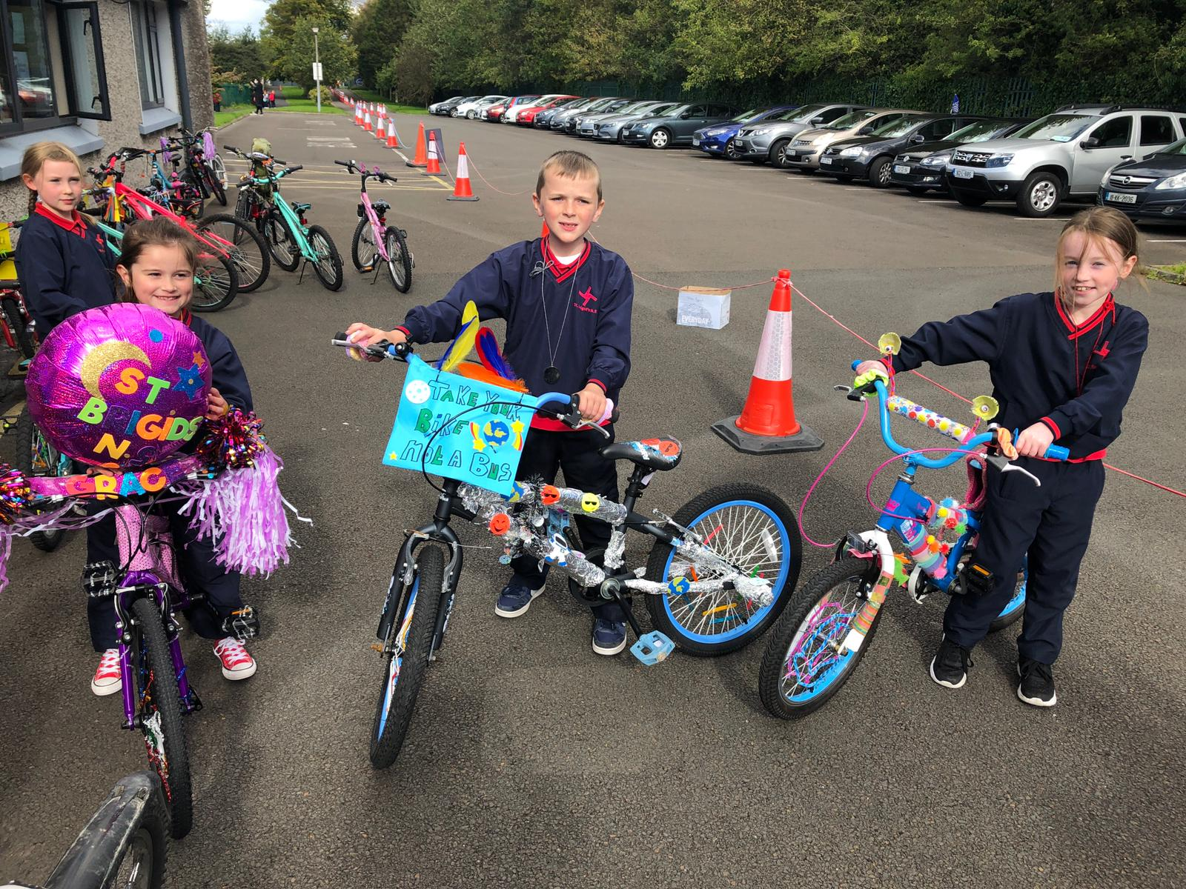

**Third Class**

Third classes have taken part in a few online events this term. They learnt a lot about number patterns on ‘Maths Week TV with Susan O Kereke. They looked at optical illusions with *Ginny Smith* as part of Science Week and they also participated in an online music workshop with Music Generation.

They spent 5 weeks working on fundamental movement skills with Peter Nash. They thoroughly enjoyed this and have acquired lots of new skills.

Ms. Fitzgerald’s class enjoyed reading the novel 'The Magic Carpet Slippers’. They loved wearing their own slippers in class! They are now making their own books using the Book Creator App.

Mr. Scanlon’s class are currently reading the novel Grandpa Chatterji’. They are really enjoying learning about India through reading the story.

**Fourth Class**

4th class enjoyed taking part in Active school week and the ‘Bling your Bike’ competition in September. We came up with some very creative ideas.

4th class were part of an online music workshop with Music Generation in October.

Both classes took part in the SOPHia Project: A science outreach programme to promote physics in primary school in November. The presenters asked questions like “why is the sky blue?” and “why do you spin faster with your legs tucked in?” A few physics principles were also included in the workshop along with experiments on static electricity etc. The workshop aimed to encourage pupils to consider physics as a lifelong career. An enjoyable experience was had by all.

We are also currently taking part in fundamental movement skills workshops with Peter Nash on Tuesdays.

**Sixth Class**

Children have been learning about WW2 and have been using the school laptops to create presentations collaboratively based on various aspects of the war.

The children took part in science week and were lucky enough to engage with UL Science Webinars. One particular workshop on space inspired our first STEM project of creating moon buggies. Check out Twitter to see some photographs!

The boys and girls took part in the TLC Christmas Card competition where they captured beautiful images of Limerick decorated for Christmas, magical sunsets and sunrises and even managed to include some wildlife.

The children created a class advent calendar which, when opened daily, reveals a fun activity to be completed such as mindfulness, exercises and much, much more!

The children put together an envelope full of compliments for one another and they read them and reflected on them. They looked at their own gifts and talents that they all have and how each child is unique and special.

The children carried out guided reading up until Christmas break and developed their reading and comprehension skills.

We also wrote Christmas songs for the Limerick hurling teams. Check out our songs on the school’s Twitter page!



**Fifth Class**

In 5th class, we have been working on projects during ‘Genius Hour.’ There is an array of different projects such as: horses, cooking, fashion, science, Harry Potter, social media etc. It has been so much fun becoming an ‘expert’ in our interests. We are looking forward to presenting them to each other in the coming weeks.

We have been giving each month a name and an activity:

Smile September: We all tried to make people smile each day and were aware that we all have so much to be thankful about and smile about in our lives.

Open October: We were open to trying new things. Some people joined new clubs, stayed off/ reduced use of screens, read more etc. It was great fun and showed us that we all have many talents.

Novel November: We were encouraged to read more books. We enjoyed taking time each day to read and some of us even found a love for reading again!

Draw December: We decided that we would work on mindfulness and take some time each day to draw while listening to music.



**General News**

We had a very active month in September with Cycle Week and Active Schools Week. We noticed a vast increase in the numbers of children cycling and scooting to school each day. Please keep this up in terms 2 and 3. A special thank you to the following:  Karen Mc Donnell and the staff at Limerick City and Council for funding  Bike Week, Limerick Sports partnership for providing cycle training for the 5th classes and repairing/ servicing the children’s bicycles.  We would also like to thank chris@evolutioncycles.ie for repairing/ servicing the bikes as well.

Active Schools Week was a huge success. There was a particular focus on the fundamental movement skills this year with an emphasis on how to walk correctly e.g. making heel-to- toe contact with the ground whilst maintaining a good posture. The staff and children were covering distances each day similar to the height of the different mountain ranges in Ireland. Well done to all involved. Please stay active each day.

**Digital Learning**

We would like to take this opportunity to thank all our parents/guardians/carers who supported St Brigid’s NS with setting up Google Classroom. We appreciate that it took some time to get used to but feel now, that if the need arises, all our children would have access to online teaching. Google Classroom will also act as a digital portfolio of the children's work as they progress through the school.

In a recent survey carried out of 330 pupils from 1st-6th class, 73% reported enjoying using laptops/ipads in school with 60% stating that they find Google Classroom useful. A statistic we would like to draw your attention to is that 53% of the pupils surveyed revealed that they are friends with people online that they do not know or have never met. This is a staggering amount of young people that either ‘follow’ strangers or allow strangers to ‘follow’ them. We would urge you all to please monitor the sites your child has access to and furthermore, monitor who has access to your son or daughters content. Please visit the following site for more resources and support

<https://www.webwise.ie/parents/talking-to-your-child-about-online-safety/>

**Whole School Events:**

**Zoom Assembly**

On the 22nd of October we had a Zoom call assembly. Some of the classes showed us what they have been doing and learning so far. The teachers picked a few people for awards for handwriting and student of the month. Ms. Ryan also gave “Principal Awards” to some students who had been working extra hard and had been behaving excellently.

**Halloween Dress-Up**

On October 23rd we dressed up for Halloween. Most classes watched movies, ate treats and had no tests. It was a very happy day for everyone and a great way to end the first few weeks of school. It was so nice to see everyone’s costumes and even the teachers dressed up too!

**World Children’s Day**

We wore odd sockson the 20th of November to represent that every child is different. All classes have also been learning about anti-bullying and being kind to others which we remembered on World Children’s Day.

**Sports** This year the students have been involved in many sports such as Tag Rugby, spike ball, soccer, trí-score, basketball and many many more.!

**Jersey Day**

On the 11th of December we had a free Green and White jersey day to support Limerick playing in the All-Ireland Senior Hurling Final. Each class also displayed signs and posters of support by colouring in pictures of the players and Limerick flags. ***We were delighted when Limerick won the match!*** We were also delighted when we were given no homework the next day to celebrate!

**We wish all our pupils, families and community a very happy and peaceful Christmas.**



**With Best Wishes,**

**The Principal & Staff of St. Brigid’s N.S.**

**Dates for your diary**

School closes at 12.00 noon Tuesday 22nd December and re-opens on Wednesday 6th January.

**Term 2**

**Midterm**: School will be closed on Thursday 18th and Friday 19th February 2021.

**Public Holiday** Wednesday 17th March

**Easter Holidays** commence at 12.00 noon on Friday 26th March. School re-opens on Monday 12th April.

**Term 3**

**Public Holiday** Monday 3rd May 2021. School will be closed for the week of 3rd to 7th of May 2021.

**Public Holiday** Monday 7th June 2021

**Summer closing:** Friday 25th June 2021