6th Class Booklist 2020-2021

Gaeilge: Graiméar Le Chéile Edco 5 agus 6

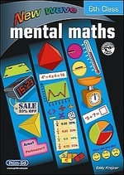
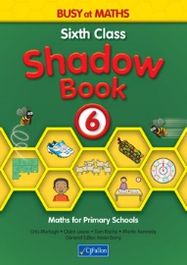
Maths: 1. Busy at Maths 6th Shadow Book
2. New Wave Mental Maths 6th Class
3. Calculator (basic)
4. Mathematical Instrument Set
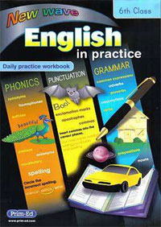
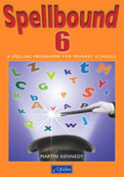
English: 1. New Wave English 6th Class
2. Spellbound 6th Class

Equipment:
Atlas (from last year), A4 document wallet, 5 x A4 hardback copies, black and red biros, HB2 pencils, erasers, long clear plastic ruler, 3 x glue sticks, small scissors, 10 x lined copies, 5 x maths copies (squares).

Expenses:
Confirmation Booklet €3
School Journal €3
Photocopying €14
Local water charge €5
Art Supplies €10
Allianz Pupil Insurance €9
Box for books €5
Total: €49

