Booklist Fifth Class 2020-2021
English: New Wave English in Practice 5th Class
Better English Literacy Skills 5th Class Activity Book (Educate.ie)

Maths: New Wave Mental Maths (Revised Edition) 5th Class
Calculator [basic, NOT scientific]
Set of Mathematical Instruments (Helix Set or Premier Set only)

- 10 x 80 page writing copies
- 5 x 80 page maths copies
- 5 large A4 button wallets
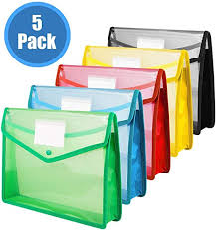
- 40 Pocket folder
- 2 glue sticks
- Crayons or colouring pencils
- 2 red biro, 4 good quality pencils, rubber, 30cm ruler, pencil parer
- Scissors
- A5 hardback notebook
Please replace any of the items 1-9 above promptly throughout the course of the year if needed. Please ensure that each item 1-9 is clearly labelled as there will be a strict no sharing policy enforced throughout the year.

Expenses
Drumcondra and Sigma T Tests No Charge
St. Brigid’s School Journal €3
Photocopying/Computer Ink €14
Woodwork Workshop €5
Art/Craft Materials €10
School Insurance €9
Water Rate €5
Storage/ Book Box (Supplied by the school) €4
Total €50

Due Back on Thursday the 27th August 2020.
The cost of swimming, visits to the library and/or Parteen Weir, guest speakers and other events will be advised throughout the year. All other books will be provided as part of the book rental scheme

